**Question 1) Let us assume we implement an AND function to a single neuron. Below is a tabular representation of an AND function:**

|  |  |  |
| --- | --- | --- |
| **X1** | **X2** | **X1 AND X2** |
| **0** | **0** | **0** |
| **0** | **1** | **0** |
| **1** | **0** | **0** |
| **1** | **1** | **1** |

**The activation function of our neuron is denoted as:**

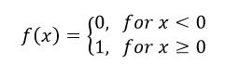

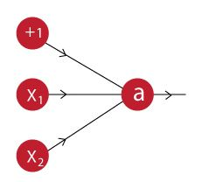

**What would be the weights and bias?**

**Question 2) In the graph below, we observe that the error has many “ups and downs”**

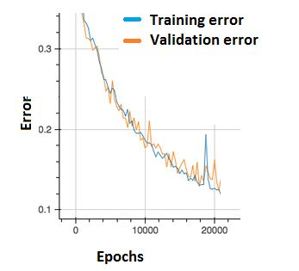

**Should we be worried?**

A. Yes, because this means there is a problem with the learning rate of neural network.

B. No, as long as there is a cumulative decrease in both training and validation error, we don’t need to worry.

**Question 3) The network shown in Figure 1 is trained to recognize the characters H and T as shown below:**

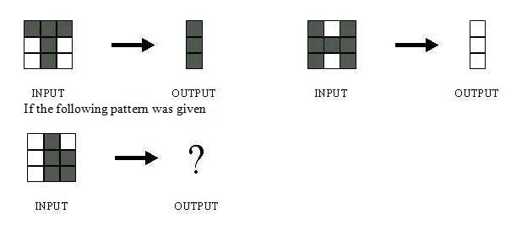

**What would be the output of the network?**

1. 
2. 
3. 

D) Could be A or B depending on the weights of neural network

Question 4)

